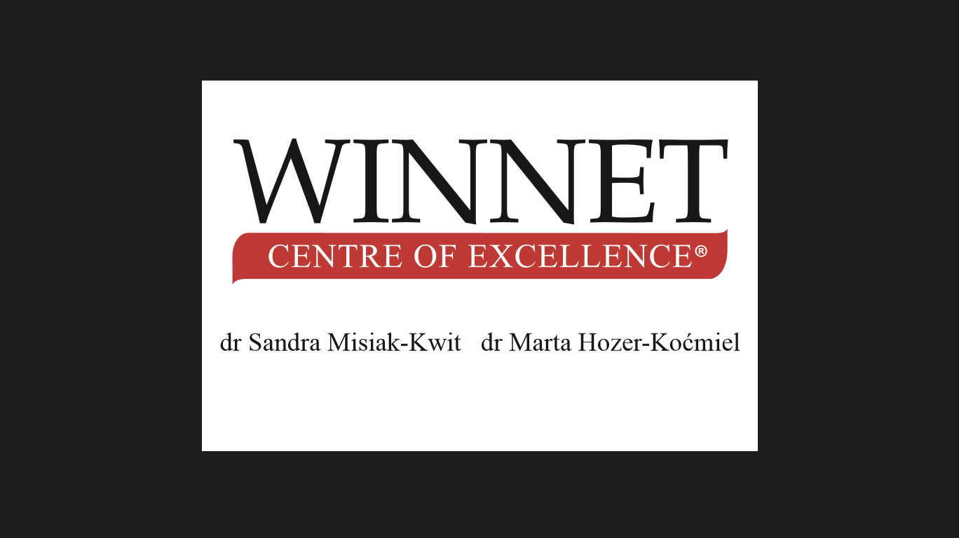

Szczecin, June 2022
Authors
Dr Anna Gdakowicz
Dr Marta Hozer-Koćmiel
Dr Sandra Misiak-Kwit
Dr Małgorzata Wiścicka-Fernando

IDEAS FOR THE FURTHER DEVELOPMENT
OF WINNET CENTRE OF EXCELLENCE®

- Integration of the members of WCE® through writing common articles, cooperation between Universities that members represent
WCE® is an organization consist of a wider human network that represents different regions and countries. This diverse approach is the unique competitive advantage for the WCE® and the fundamental challenge is how to utilize it effectively. As a solution, it can be done thru a common publication. As a WCE®, it is one of our priorities to conduct collaborative research with the integration of our members. The collaborative research is an integral part of the knowledge creation process. Some benefits can be gained through collaborative research and among them Expertise involvement, research area specialization, a different point of view, and comparative analysis are significant.

As a woman organization, we would prefer to focus on the research areas such as gender equality, women and enterprises, women and business leadership, sustainable development, and Millenium Development Goals, but we are open to other research areas as well. The subject of the article will depend on the researcher's scientific interests and areas. One of the main aims of this proposal is to integrate knowledge, experience, and data from multiple countries. The policymakers, academics and the general public also will be directly or indirectly benefited from this proposed integration. At the same time, it will be an opportunity for universities that members represent to utilized their competencies under one platform to the betterment of the Baltic Sea Region and its further advancement.

- Conferences – participation in conferences and seminars organized by other institutions all around the world + organization of the WCE® Conferences or Summer Schools

Depending on the financing, we propose participation in TWO significant scientific conferences. This will allow to promote both the goals of the project, as well as all partners/ institutions. An exemplary scientific conference is the "Microeconometrics in theory and practice, organized by the University of Szczecin, once every two years. The next edition is in September 2021 in Szczecin, Poland. Participation in each 'external' conference of the project should be supported by a highly scored scientific article. TWO internal CONFERENCES, or rather seminars, organized by partners on a smaller scale. Participants are essentially the project partners, or possibly practitioners cooperating with the partner. The main goal of internal conferences will be to connect practitioners and theorists dealing with entrepreneurship taking into account the gender perspective. The main goal of the external conferences will be the internationalization of research results on entrepreneurship, taking into account the gender aspects.

- Exchange of knowledge on gender equality in economics and management during Sabbatical leaves – the members and experts of WCE® can visit the other Academias or institutions for a certain period of time from 1 week till 3 months depending of the financial means.
The direct exchange of knowledge about gender equality in economics and management - whether during a personal visit to another university or during direct contact on line - has many advantages. Above all, it is an opportunity to learn about the situation of gender equality by staying in another country not only on the basis of other people's stories, but also by staying directly. The opportunity to talk directly about possible gender inequalities - looking for the causes of problems and possibilities of solving them. Exchange of "good practices" - what solutions can be proposed by the visitor, but also what solutions applied in the host country are worth disseminating. The direct exchange of knowledge may result in the establishment of academic cooperation (and the creation of research articles), but it may also contribute to a broad scientific and economic cooperation, including student exchange.
The length of the stay in another country will be determined by the financial possibilities and the sanitary requirements of each country. It should be emphasized, however, that personal contact is preferred as far as possible, which allows to get to know better the conditions in the visited country, and encourages to establish cooperation and often also friendship.

- Publishing another number of WCE® Series; 5 of them has been already published. It can be a paper or/and electronic version.

The Winnet Centre of Excellence® Series, issued in English, is an edited once a year continuous publication. Three numbers have been already published, and fourth is in a review process. In the first number authors explore the problem of inequalities in management and economics. In number two authors describe development of women. Those two numbers are published by University of Kelaniya in Sri Lanka. Third edition is a collection of works devoted to the topic of diversity and published by Saimedo in Geargia. Fourth number will be published by Vilnius University Press in Lithuania and is titled “Sustainability – Equality – Women” (eds.: S. Misiak-Kwit, I. Kiausiene). Altogether authors represent such countries as Armenia, Estonia, Finland, Georgia, Germany, Lithuania, Poland, Sri Lanka, Sweden, Vietnam.
One number of our Series can be devoted to problems analysed in INTERACTWIN project. Proposition for titles: “Women’s enterprises – Innovation and Business models” or “Development and growth in the COVID time”. Invitation to submit papers will be send to all members, project partners, colleaguges etc. Depending on finance next number can be published in chosen country (we can choose among those represented by WCE® members).

References:
S. Misiak-Kwit, M. Hozer-Koćmiel (eds.), INEQUALITIES IN MANAGEMENT AND ECONOMICS, Winnet Centre of Excellence® Series, No 1, Department of Marketing Management; University of Kelaniya, Kelaniya, 2016.
S. Misiak-Kwit, M. Wiścicka (eds.), DEVELOPMENT OF WOMEN AND MANAGEMENT, Winnet Centre of Excellence® Series, No 2, Department of Marketing Management; University of Kelaniya, Kelaniya, 2017.
S. Misiak-Kwit, N. Gorgadze (eds.), THE CHALLENGE OF DIVERSITY, Winnet Centre of Excellence® Series, No 3, Saimedo, Tbilisi, 2018.

- Development of tools and methods for gender equality analyses e.g tools for activating women in the labour market, tools for analyzing unpaid work in economy, tools for analyzing economic convergence of regions from gender perspective

Internationalisation of Tools and methods used by scientists participating in the project. Each of the partner, members of the Winnet Center of Excellence, shares two methods. For example, the University of Szczecin uses quantitative, statistical methods to study the relationship between economic growth and the gender factor. University of Szczecin team support groups for women entrepreneurs using the BST Business Succes Teams method.

